Parity Distribution — Sri Lanka Birth Registration

Figure 1: Birth Order Distribution
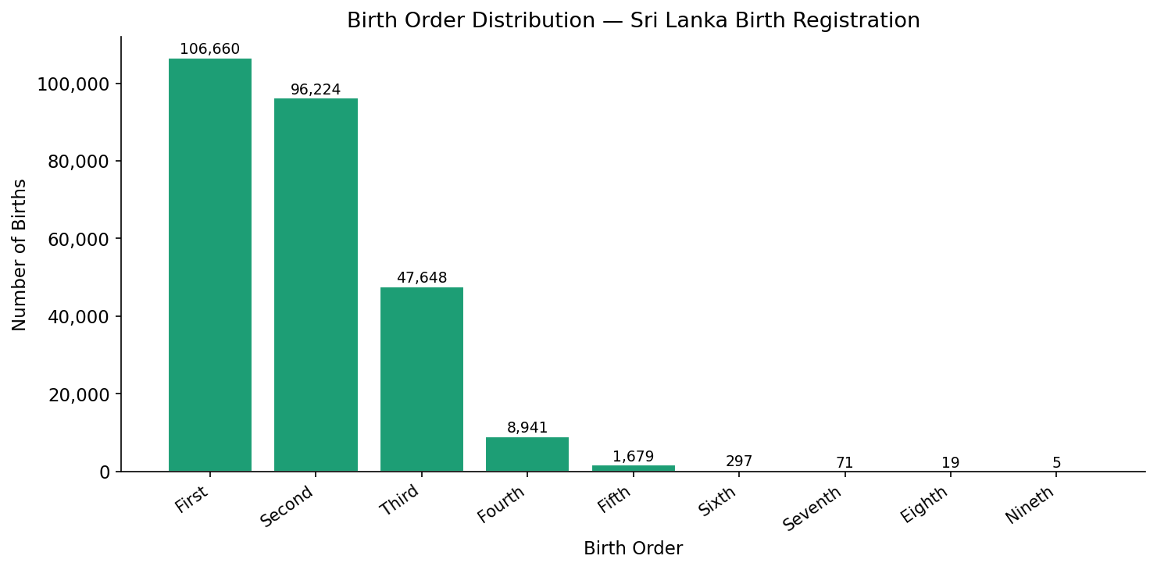

Table 1: Frequency Distribution of Birth Order
Birth Order | Parity | Frequency | Percentage % | Cumulative %
First | 1 | 106,660 | 40.78% | 40.78%
Second | 2 | 96,224 | 36.79% | 77.57%
Third | 3 | 47,648 | 18.22% | 95.79%
Fourth | 4 | 8,941 | 3.42% | 99.21%
Fifth | 5 | 1,679 | 0.64% | 99.85%
Sixth | 6 | 297 | 0.11% | 99.96%
Seventh | 7 | 71 | 0.03% | 99.99%
Eighth | 8 | 19 | 0.01% | 100.00%
Nineth | 9 | 5 | 0.00% | 100.00%
Total |  | 261,544 | 100.00% | 100.00%

Note: Parity refers to the number of live births a mother has had.

